# SPRINT - 2

|  |  |
| --- | --- |
| Date | 05 November 2022 |
| Team ID | PNT2022TMID00730 |
| Project Name | Skill and Job Recommender |
| Maximum Marks | 20 Marks |

SPRINT –3 TASK :

-UPLOAD RESUME

# RECOMMENDATION BASED ON PROFILE

* **SKILL RECOMMENDATION BASED ON JOB ROLE**

Upload Resume :

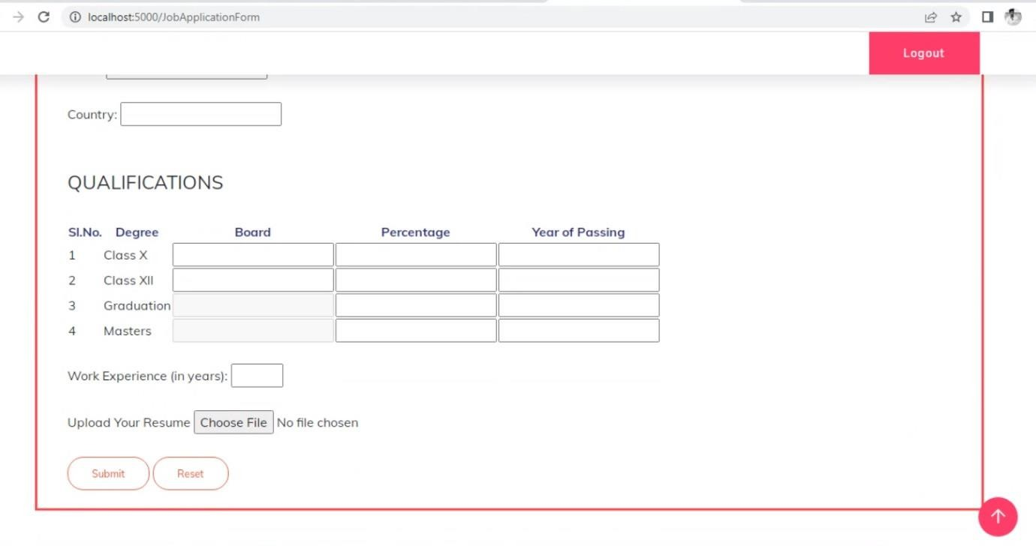

Recommendation Based on Profile :

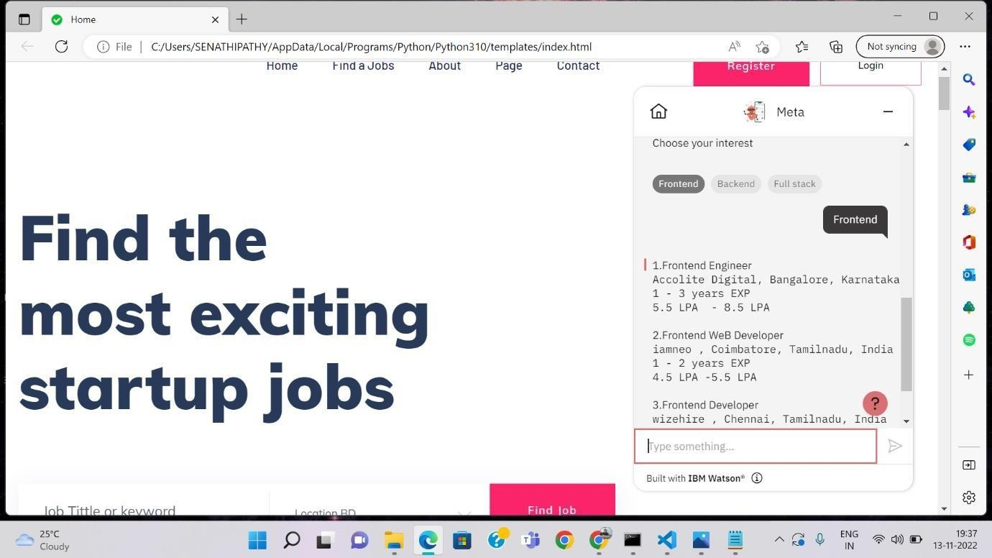

Skill Recommendation Based on Job Role :

